Website | Time | Reason | Number to screenshot
ChatGPT | 9.54 | To just generative ai to generate what it thinks the NFR/FR/UAC for the task given to help me check if I have missed anything | 1
https://github.com/jerry-sinefeld/occupational-specialism- | 9.09 | To view past work on peers githubs | 2

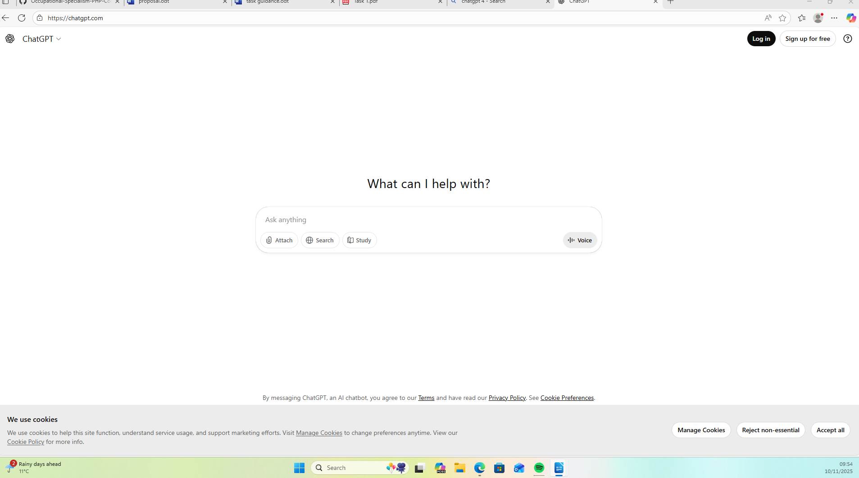
1.

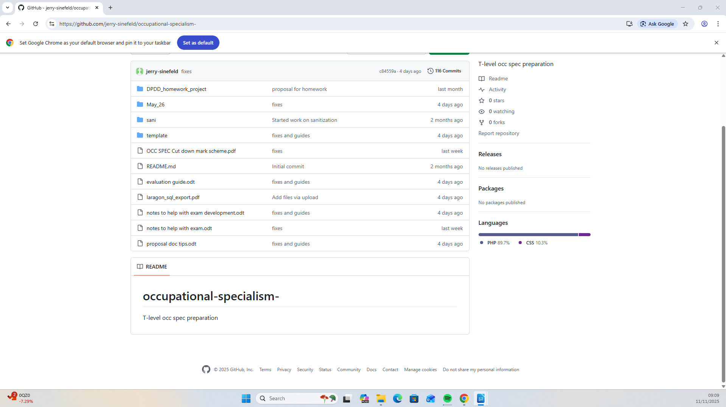
2.

